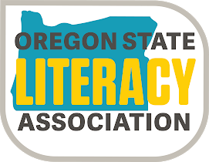
Patricia Gallagher Picture Book Award

Each child votes for their favorite book

The award is named for Patricia Gallagher, a retired Western Oregon University professor of children’s literature and former OSLA president.

Nominees for the 2023 Award
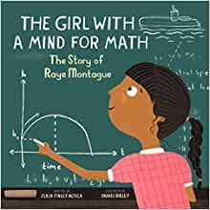
The Girl With A Mind For Math: The Story of Raye Montague
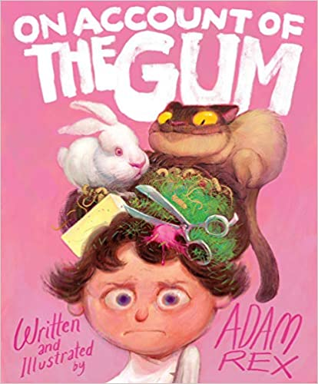
by Julia Finley Mosca Illustrated by Daniel Rieley

On Account Of The Gum
by Adam Rex

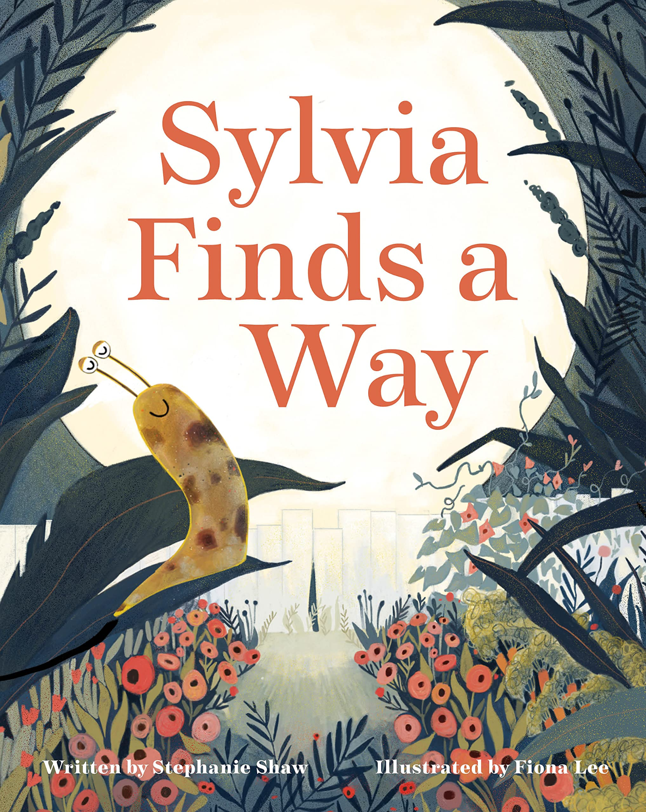

Sylvia Finds A Way
by Stephanie Shaw
Illustrated by Fiona Lee

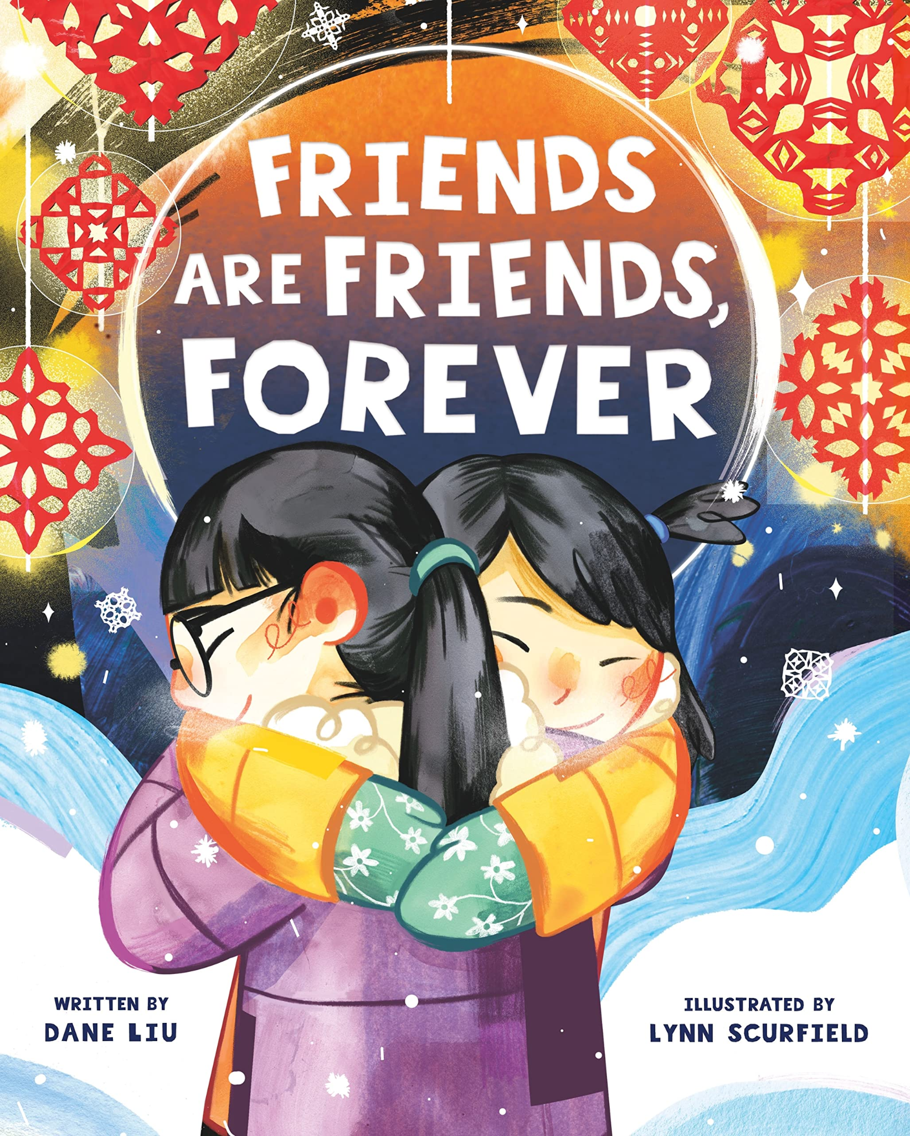

Friends Are Friends Forever
by Dane Liu
Illustrated by Lynn Scurfield

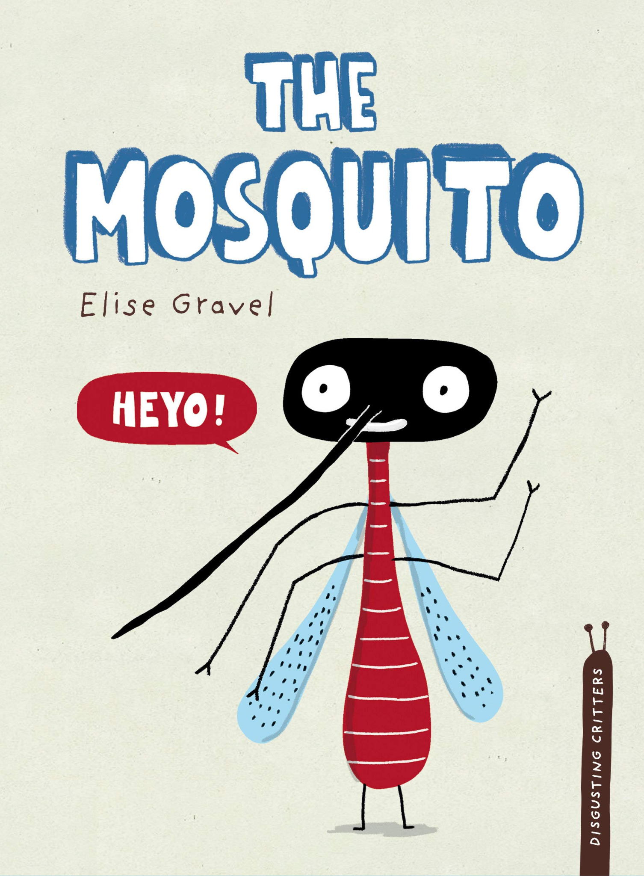

The Mosquito
by Elise Gravel

About The Award
The award was founded in 1997 as a way to promote literacy and a love of reading--one of the goals of the Oregon State Literacy Association. The books are chosen by a committee of OSLA leaders, teachers, school and public librarians. The books must be readily available in paperback, be no more than ten years old, hold an innate appeal to children, have quality text and illustrations, and work well as a read-aloud.

Who May Vote?
Oregon school children of all ages are eligible to vote. Children vote for their favorite title. This is not a group/class vote.

When To Vote
Voting occurs between September 1st and May 1st. Votes must be reported by May 1, 2023.

Reporting Votes
Report votes by using the Google Form found on the OSLA website (oregonread.org) on the Patricia Gallagher Award page.

Questions?
Contact Cara Miller: PGAward@oregonread.org

